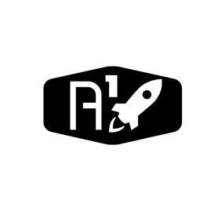

DESIGN DOCUMENT

Area : Converse Engine

Category: Feed (Piping)

TEAM: Propulsion

Nyameaama Gambrah

SubController Program

Sensor Calculation

SBC Program Loop

From ECU

Request

SPI Interrupt

Handler

Permanent Storage

Update New Value

Remove Old Value

Value Table